New York City is the most populous city in the United States. With an estimated 2019 population of 8,336,817 distributed over about 302.6 square miles (784 km2), New York City is also the most densely populated major city in the United States. Located at the southern tip of the U.S. state of New York, the city is the center of the New York metropolitan area, the largest metropolitan area in the world by urban landmass. With almost 20 million people in its metropolitan statistical area and approximately 23 million in its combined statistical area, it is one of the world's most populous megacities. New York City has been described as the cultural, financial, and media capital of the world, significantly influencing commerce, entertainment, research, technology, education, politics, tourism, art, fashion, and sports.

This Capstone Project aim to create an analysis of features for a people migrating to Manhattan to search a best neighborhood as a comparative analysis between neighborhoods. The features include median housing price and better school according to ratings, crime rates of that particular area, road connectivity, weather conditions, good management for emergency, water resources both fresh and waste water and excrement conveyed in sewers and recreational facilities.

It will help people to get awareness of the area and neighborhood before moving to a new city, state, country or place for their work or to start a new fresh life.

## 2. Data Section

Data was gathered from newyork_data.json file from one of the lab exercise for this project.

#### **Foursquare API Data:**

We will need data about different venues in different neighborhoods of that specific borough.  
In order to gain that information we will use “Foursquare” locational information. Foursquare is a location data provider with information about all manner of venues and events within an area of interest. Such information includes venue names, locations, menus and even photos. As such, the foursquare location platform will be used as the sole data source since all the stated required information can be obtained through the API.

After finding the list of neighborhoods, we then connect to the Foursquare API to gather information about venues inside each and every neighborhood. For each neighborhood, we have chosen the radius to be 100 meter.

The data retrieved from Foursquare contained information of venues within a specified distance of the longitude and latitude of the postcodes. The information obtained per venue as follows:

1. Neighborhood

2. Neighborhood Latitude

3. Neighborhood Longitude

4. Venue

5. Name of the venue e.g. the name of a store or restaurant

6. Venue Latitude

7. Venue Longitude

8. Venue Category

## 3. Methodology Section

#### **Clustering Approach:**

To compare the similarities of two cities, we decided to explore neighborhoods, segment them, and group them into clusters to find similar neighborhoods in a big city like New York . To be able to do that, we need to cluster data which is a form of unsupervised machine learning: k-means clustering algorithm.

**Using K-Means Clustering Approach** | Most Common Venue

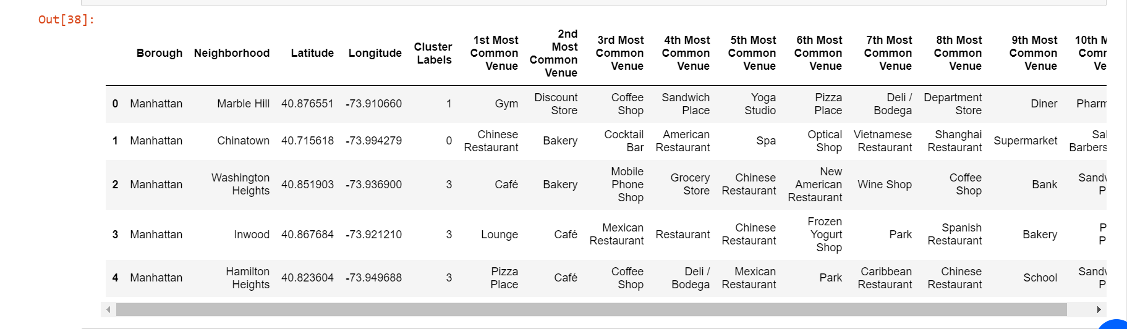

**Most Common Venues near Neighborhood** | Using Clustering

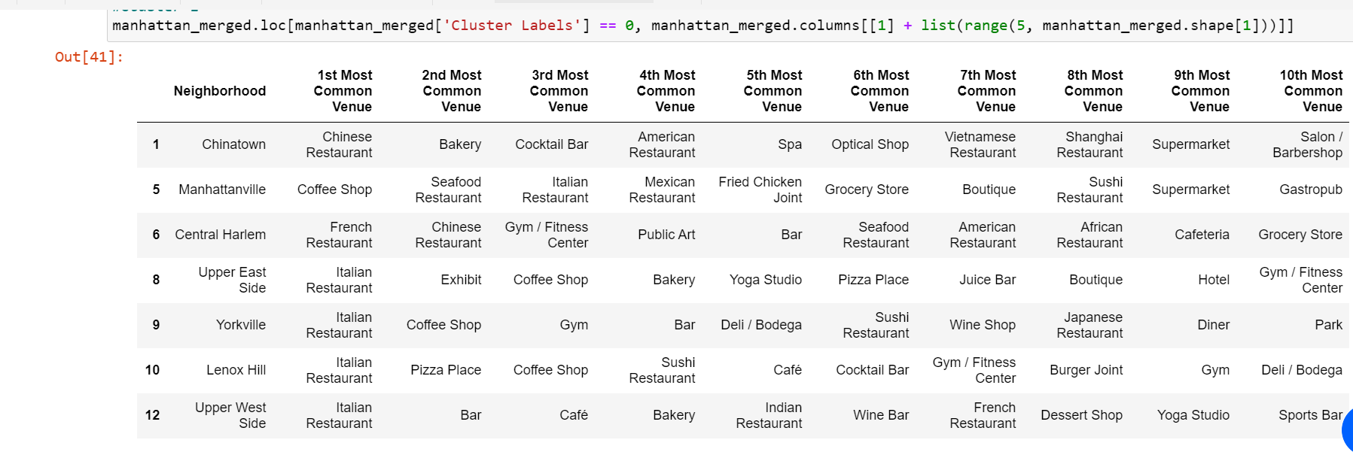

#### **Work Flow:**

Using credentials of Foursquare API features of near-by places of the neighborhoods would be mined. Due to http request limitations the number of places per neighborhood parameter would reasonably be set to 100 and the radius parameter would be set to 500.

## 4. Results Section

**Map of Clusters in Manhattan**

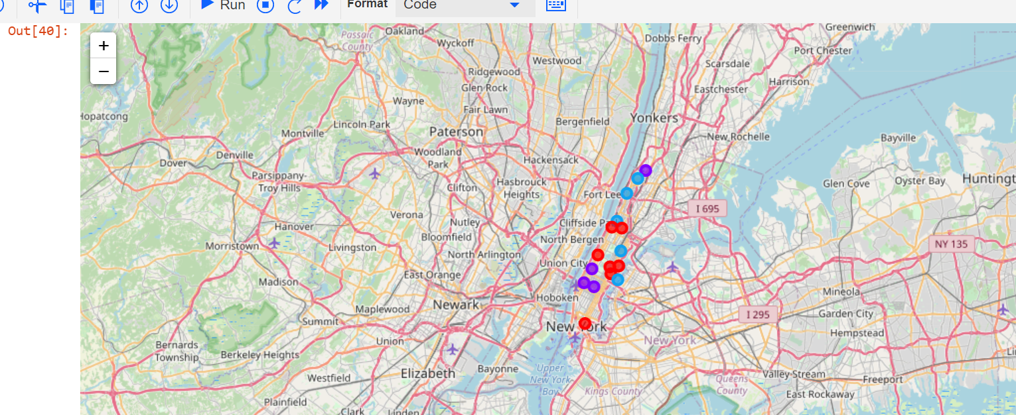

**Average Housing Price by Clusters in Manhattan**

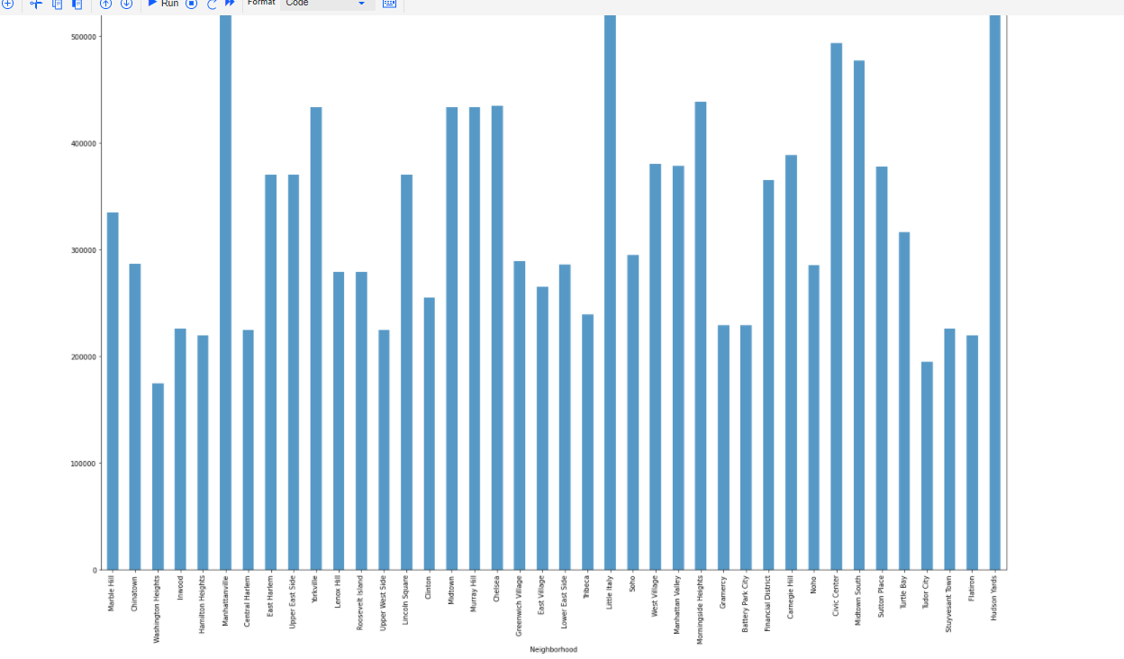

**School Ratings by Clusters in Manhattan**

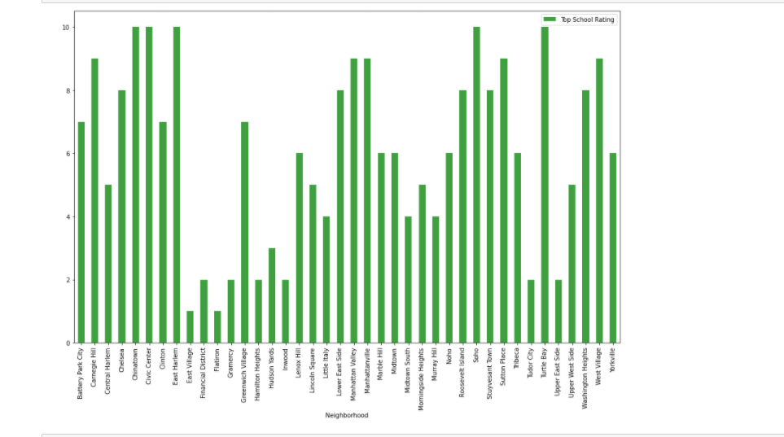

#### **The Location:**

Manhattan is a popular destination for new immigrants in US to reside. As a result, it is one of the most diverse and multicultural, being home to various religious groups and places of worship. Although immigration has become a hot topic over the past few years with more governments seeking more restrictions on immigrants and refugees, the general trend of immigration into United States has been one of on the rise.

#### **Foursquare API:**

This Capstone project have used Four-square API as its prime data gathering source as it has a database of millions of places, especially their places API which provides the ability to perform location search, location sharing and details about a business.

## 5. Discussion Section

#### **Problem Which Tried to Solve:**

The major purpose of this project, is to suggest a better neighborhood in a new city for the person who are shifting there. Social presence in society in terms of likeminded people. Connectivity to the airport, bus stand, city center, markets and other daily needs things nearby.

* Sorted list of house in terms of housing prices in a ascending or descending order
* Sorted list of schools in terms of location, fees, rating and reviews

## 6. Conclusion Section

In this Capstone project, using k-means cluster algorithm I separated the neighborhood into 10(Ten) different clusters and for 103 different latitude and longitude from dataset, which have very-similar neighborhoods around them. Using the charts above results presented to a particular neighborhood based on average house prices and school rating have been made.

I feel rewarded with the efforts and believe this course with all the topics covered is well worthy of appreciation.  
This project has shown me a practical application to resolve a real situation that has impacting personal and financial impact using Data Science tools.  
The mapping with Folium is a very powerful technique to consolidate information and make the analysis and decision better with confidence.

#### **Future Works:**

This Capstone project can be continued for making it more precise in terms to find best house in Manhattan. Best means on the basis of all required things (daily needs or things we need to live a better life) around and also in terms of cost effective.